**Class Activity – Lesson 14**

1. Did you attend class today (8 pts)
2. Were you on time to class today (4 pts)?

A crackerjack statistics student in Brother Cromar’s class claims that the mean heart rates for at least one of the class ranks are different at BYU-Idaho. You assume that the class survey gathered at the beginning of the semester is a random sample of the BYU-I population and you use a level of significance (α=0.05). Is there evidence to conclude that at least one of the mean heart rates is different across class ranks?

1. (1 pt) State the null and alternative hypothesis for this study.

**Ho:µ1= µ2 =µ3 Ha:At least one of the population means is different**

(1 pt) Display the descriptive statistics for ANOVA.

|  |  |  |  |  |  |  |  |  |
| --- | --- | --- | --- | --- | --- | --- | --- | --- |
| **Descriptives** | | | | | | | | |
| Heart | | | | | | | | |
|  | N | Mean | Std. Deviation | Std. Error | 95% Confidence Interval for Mean | | Minimum | Maximum |
| Lower Bound | Upper Bound |
| JR | 88 | 73.06 | 14.876 | 1.586 | 69.90 | 76.21 | 15 | 120 |
| SO | 54 | 73.22 | 12.804 | 1.742 | 69.73 | 76.72 | 40 | 107 |
| SR | 46 | 72.76 | 13.694 | 2.019 | 68.69 | 76.83 | 42 | 108 |
| Total | 188 | 73.03 | 13.949 | 1.017 | 71.02 | 75.04 | 15 | 120 |

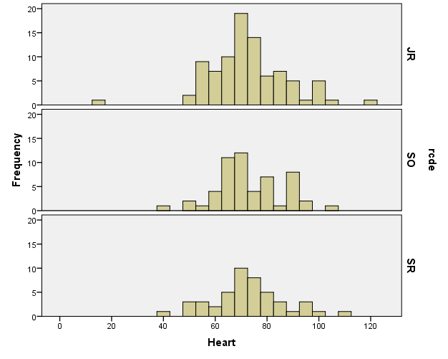

1. (1 pt) Check the requirement that the populations are normally distributed.

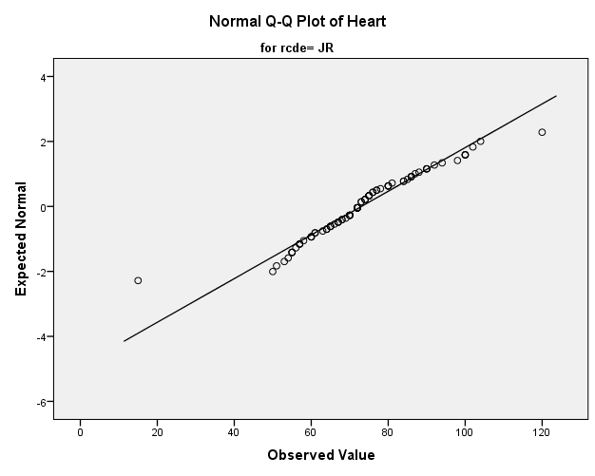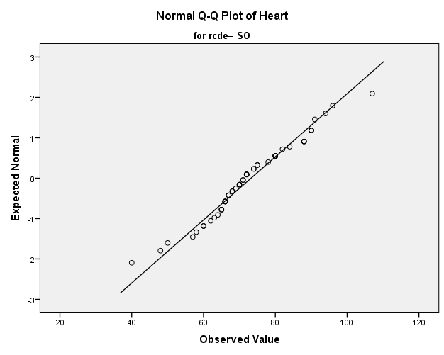

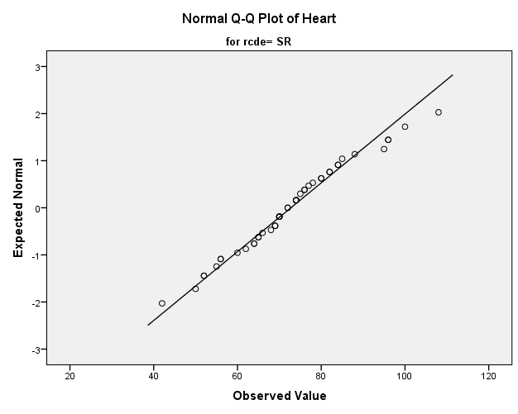

**There may be issues with normality with the Juniors (with the one outlier) but the requirement appears to be met.**

(1 pt) Does the requirement of equal variances hold? Why?

**Yes it does, since the largest variance is no more than four times the smallest variance.**

Regardless of your answers in 6 and 7, please continue with the rest of the problem.

1. (1 pt) Record the F-statistic. **0.014**
2. (1 pt) Record the degrees of freedom **2 and 185**
3. (1 pt) Record your P-value. **P-value = 0.986**
4. (1 pt) What decision do you make based on the P-value and level of significance (α)?

**Since the p-value is greater than the level of significance, we do not reject the null hypothesis.**

1. (1 pt) State your conclusions in an English sentence.

**We have insufficient evidence to say at least one of the population means differ.**

1. (1 pt) When would you use a One Sample t test in general? Also, come up with an example.

**When we are testing for one mean and we do not know the standard deviation. If the national mean of babies’ weight at birth 20 oz., you want to test to see if the mean weight is different than 20 and you do not know the population standard deviation.**

1. (1 pt) When would you use a Matched-Pair test in general? Also, come up with an example.

**When you have two dependent samples and you want to get the mean difference between the samples like comparing pre-test vs post-test for a statistics class. Who is in the pre-test sample tells you who is in the post-test sample.**

1. (1 pt) When would you use Independent Samples test in general? Also, come up with an example.

**Compare Means from Two Independent Samples.** **You want to test if the mean of male test scores is different than the mean of female test scores. Take a random sample of each gender and get a mean score for each gender and compare means**. **Who is in the male sample, tells you nothing about who is in the female sample.**